Real-time communication with Django Channels and Websockets

Transcript of   
<https://www.youtube.com/watch?v=cw8-KFVXpTE&ab_channel=DennisIvy>  
Prepared by Nicholas Holtman

In this video we'll use Channels and Websockets to create an oversimplified real-time chat application.

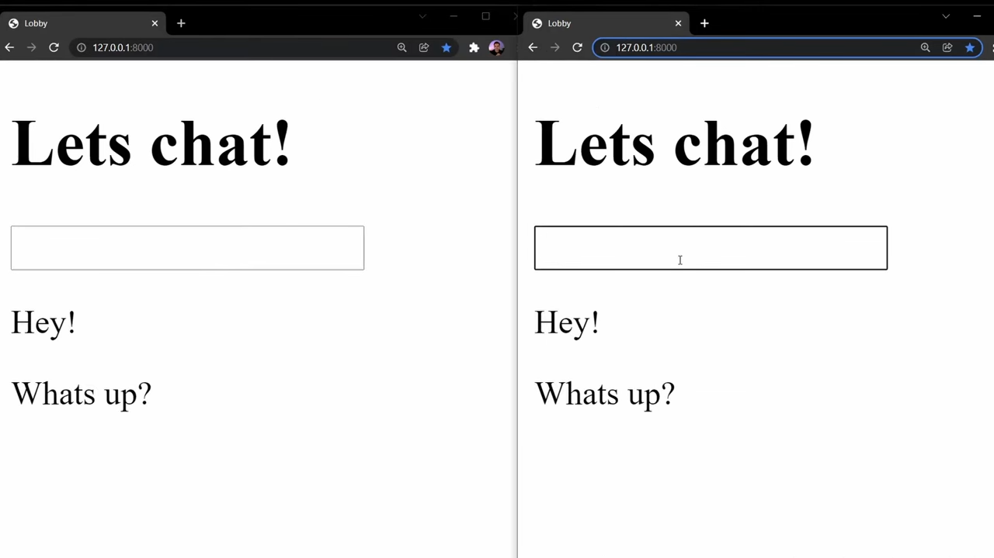

But before we get started, what are Django channels? Channels is a Django project that takes Django and extends its abilities beyond HTTP to handle

- Websockets

- chat protocols

- IOT protocols

- and more

It's built on a Python specification called ASGI (Asynchronous Server Gateway Interface). In this project we'll use Channels along with Websockets to establish a two-way communication and open connection between our client and server. We'll use Websockets on the client side to initiate a connection and channels on the server side to receive and send requests back to the client.

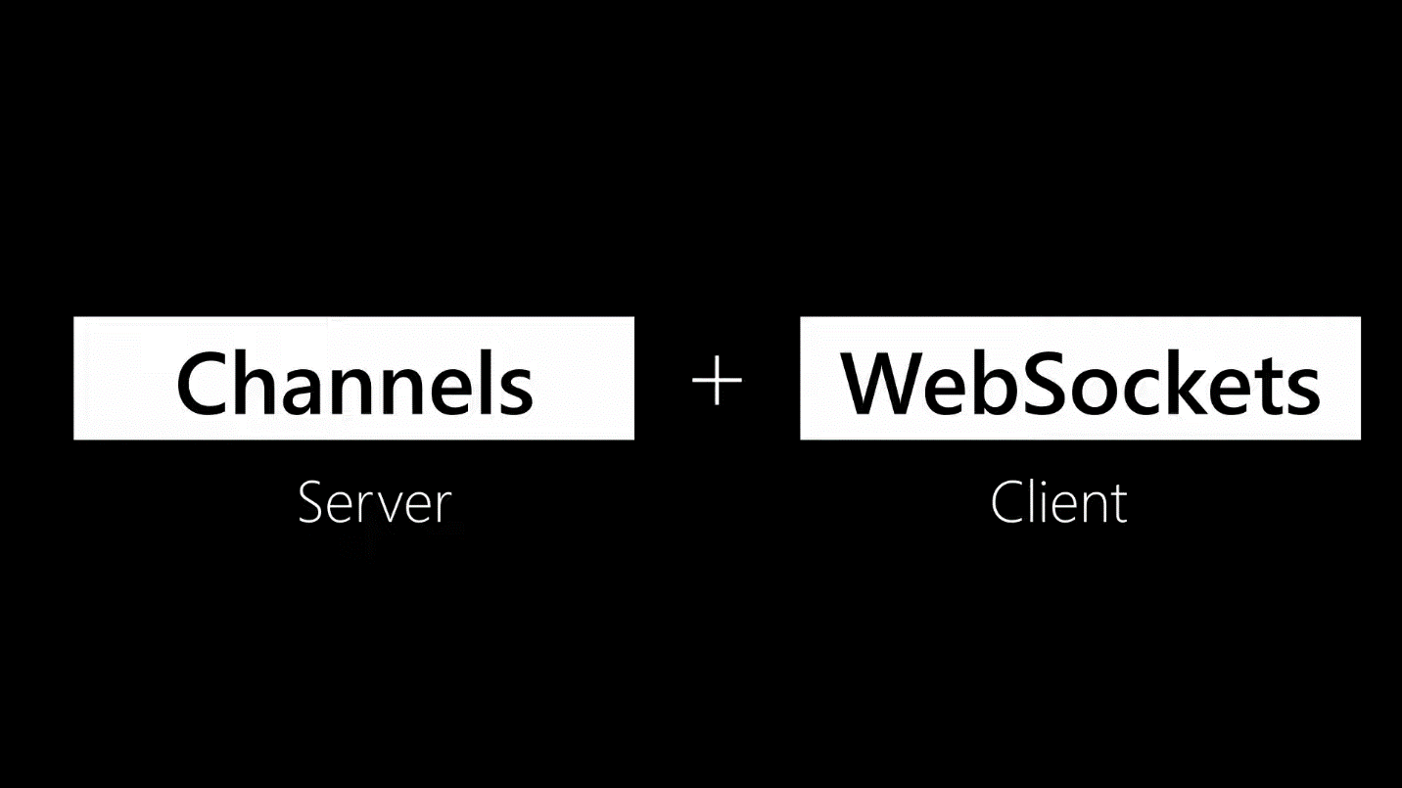

With Django Channels there are four key steps that we need to go through to set up our server and create a socket connection.

1. First we'll need to switch our Django project to use ASGI and complete some basic Channels configuration after installation.
2. Then we'll need to create some consumers, which are the channel's version of Django views.
3. Once we have our consumers we'll need to create some routing to handle the URL routing for these consumers.
4. When the channel setup is complete we'll use the built-in JavaScript Websocket API on the client side to initiate the handshake and create an open connection between our client and server.

To get things started I'll set up a simple application and render out a single template to represent our chatroom. I'll go ahead and assume you already know some basics of Django since you're learning a more advanced topic like Channels, so let's go through this setup as fast as possible. From your terminal, create a project called "mywebsite", cd into the project, and set up an app called chat.

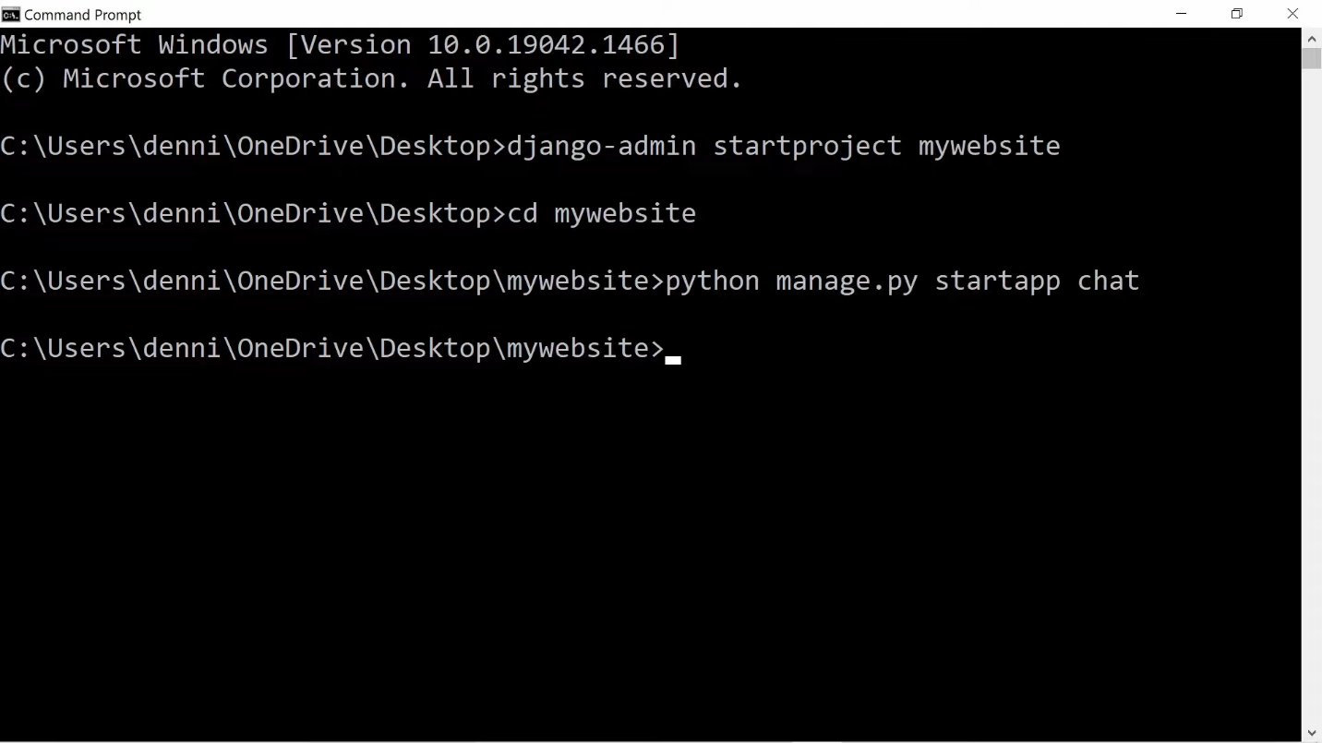

Using the text editor of your choice, open up your project files and go into settings.py and configure the app we just created inside of INSTALLED_APPS.

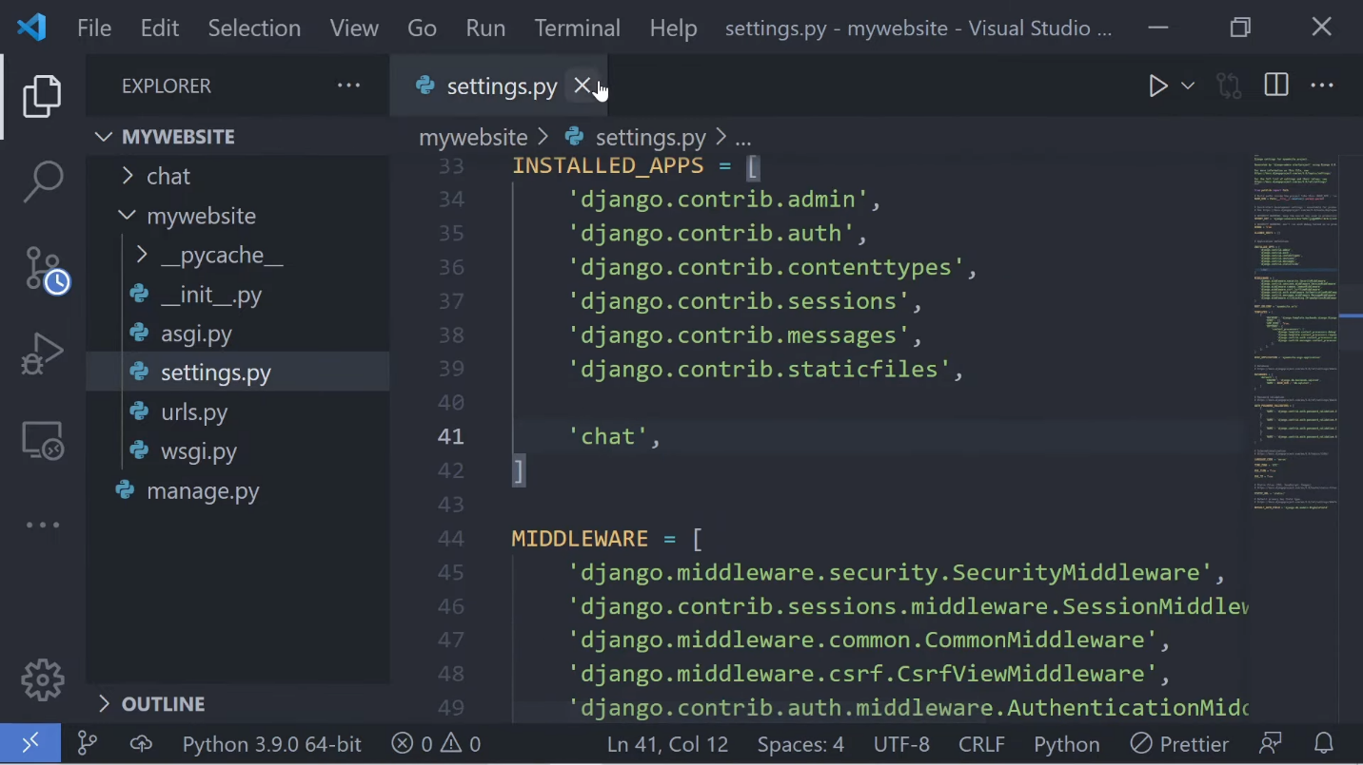

Let's jump into the apps folder and create a folder called "templates", and in the templates folder create another folder called "chat". (If you named your app differently this folder would have a different name, but because my app is called "chat" the folder inside of the templates folder will be called "chat".) Let's create a template and call it "lobby", and in here we'll want to create some boilerplate code for our HTML. I'll just remove the external CSS and JavaScript files since we'll do everything inline, and I'll also update the title tag. Let's also quickly add in some text here so we can actually see something when we first open up this website.

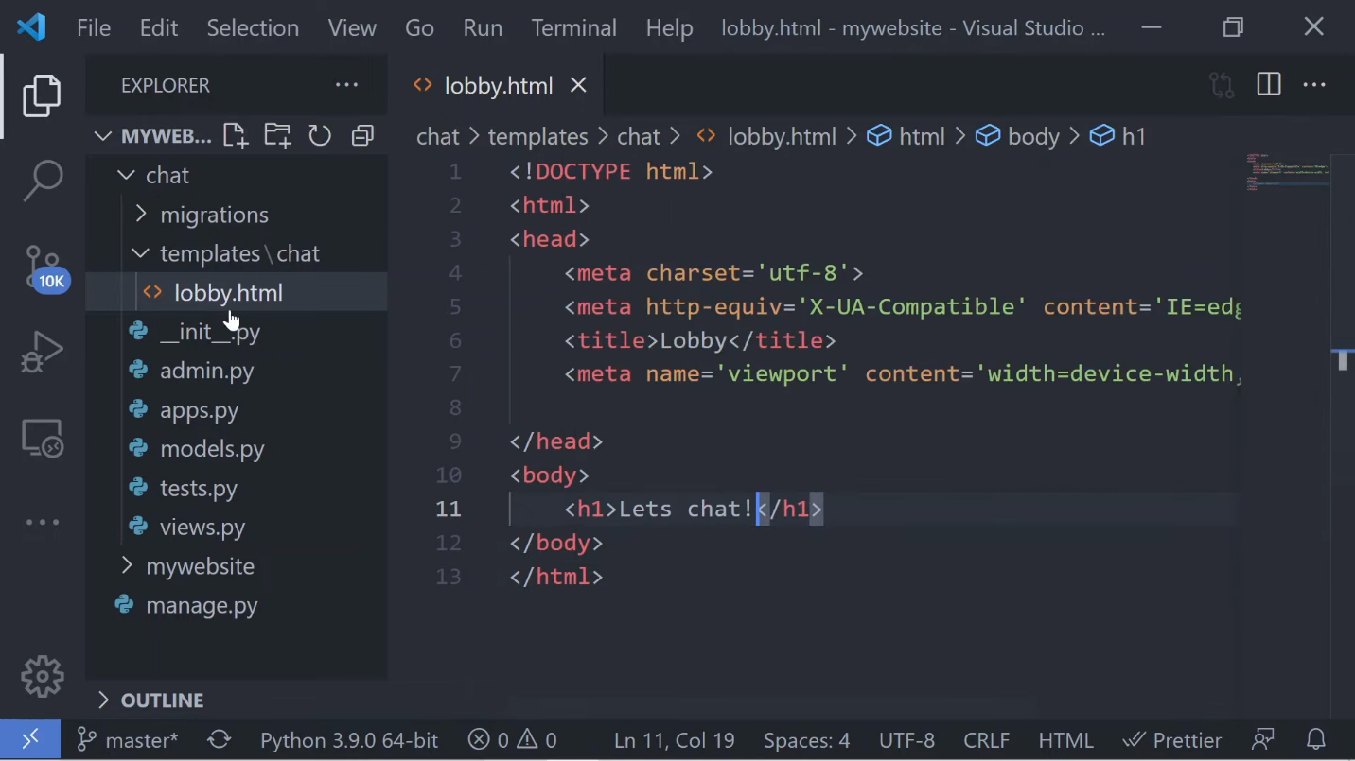

Now that we have our template, let's jump back into the views.py file and set up a view called "lobby" and return the template that we just created for this app.

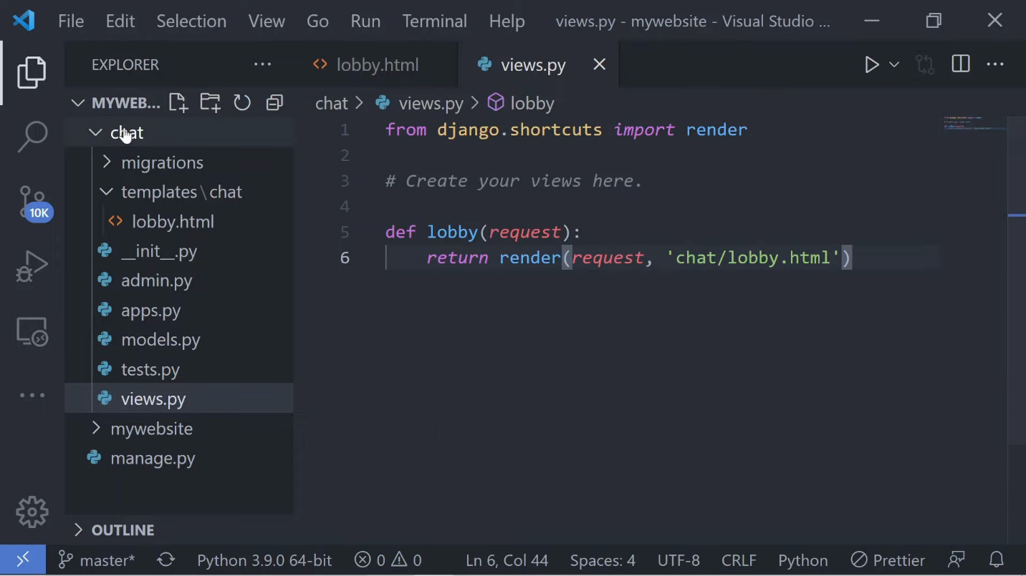

We'll need some URL routing so let's create a urls.py file and import the path function along with our views and then create a URL patterns list. In this list let's go ahead and use the path function to set a URL route and return our lobby view.

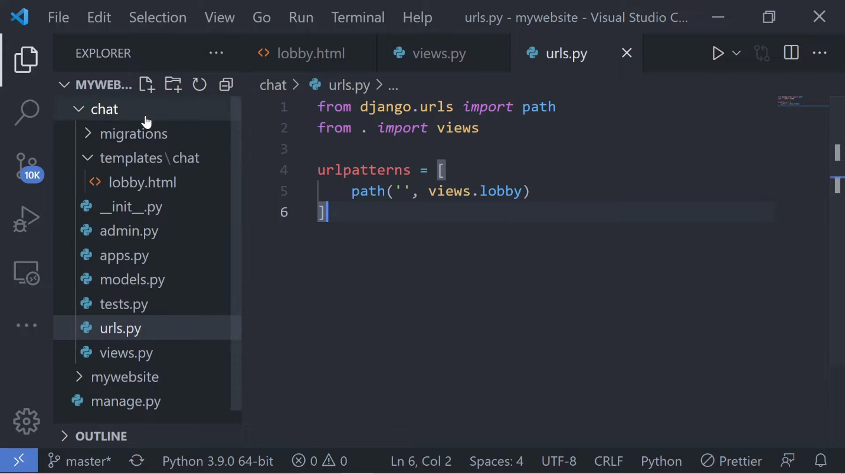

Last thing we'll want to do here is jump back into our root urls.py file, import the include method, and set the route to our app's urls.py file using the include method.

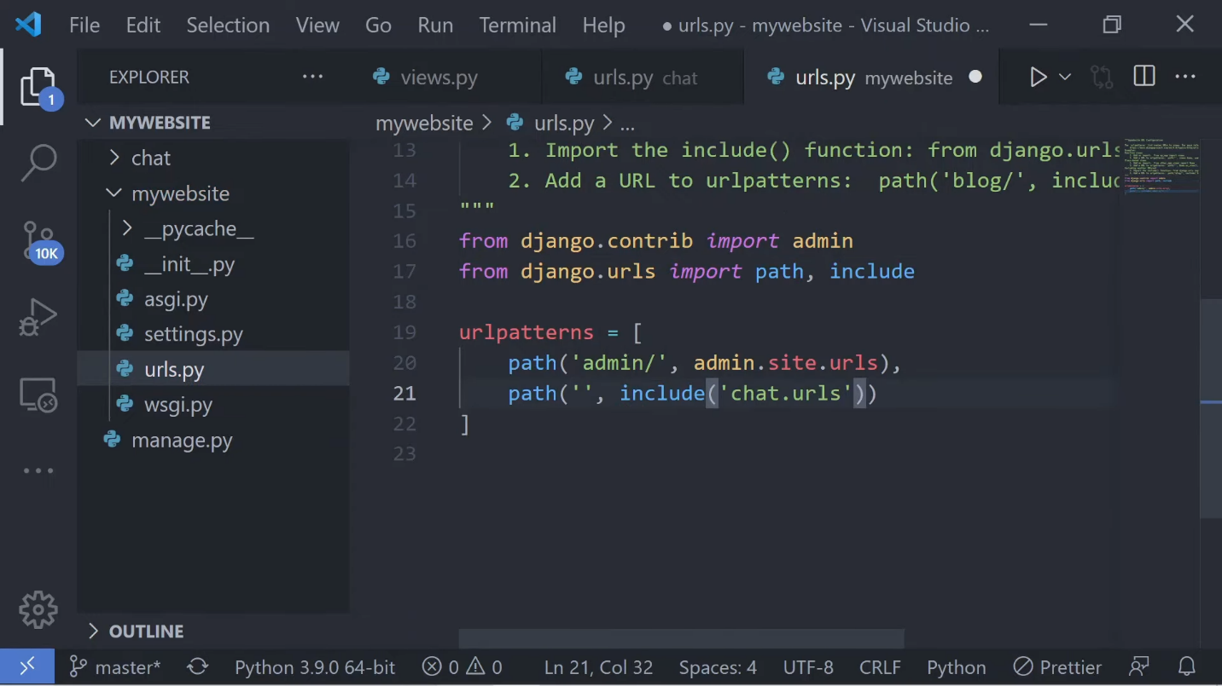

Just to make sure all is working well let's go back to the terminal and use the run server command (python manage.py runserver) to start up our server, then open up the browser on the specified port that's listed here in the terminal.

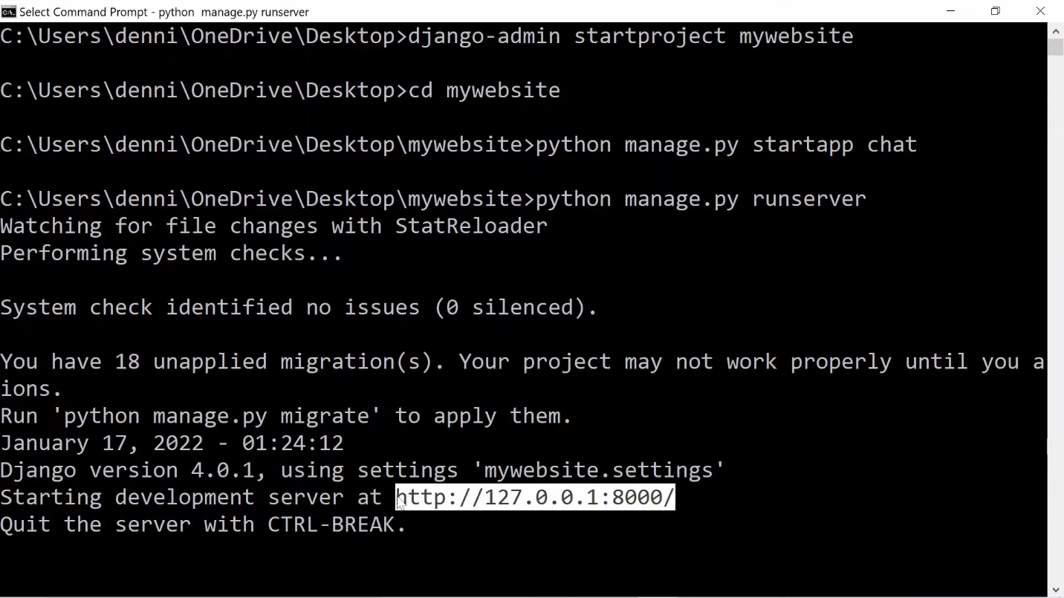

If you're seeing this response then everything went correctly here and we're ready to move on to installing and setting up Channels in our application.

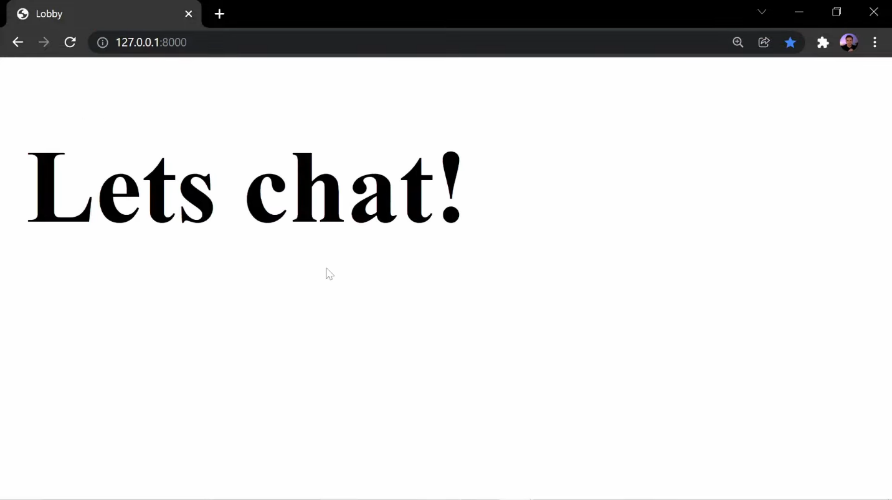

To install Channels open up your terminal and run pip install channels. Once Channels is installed, let's close out all of our tabs and open up settings.py to add Channels to our list of installed apps. Just so we don't have any conflicts, let's add Channels to the top of the INSTALLED_APPS list.

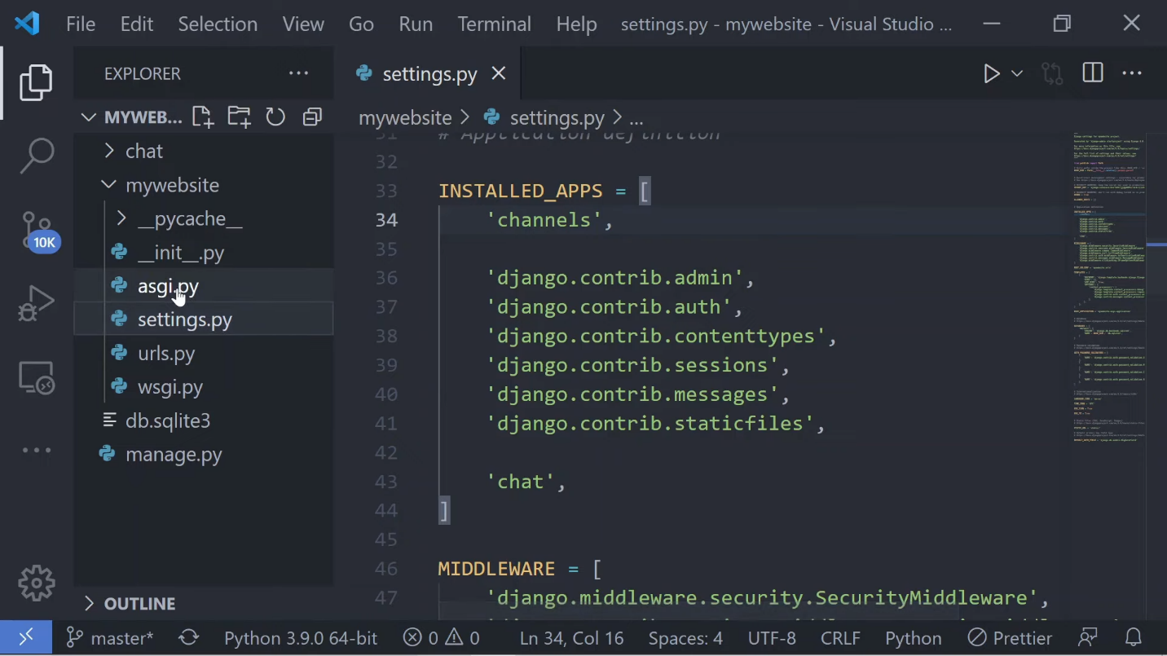

Now it's time to integrate Channels, so let's start by creating the routing configuration. A channel's routing configuration is an ASGI application that is similar to a Django configuration in that it tells Channels what code to run when an HTTP request is received by a channel server. In the asgi.py file, import ProtocolTypeRouter from channels.routing. Change the value of application to use the newly imported ProtocolTypeRouter and add "http" for now as the first value. We'll update this later when we add in other protocols.

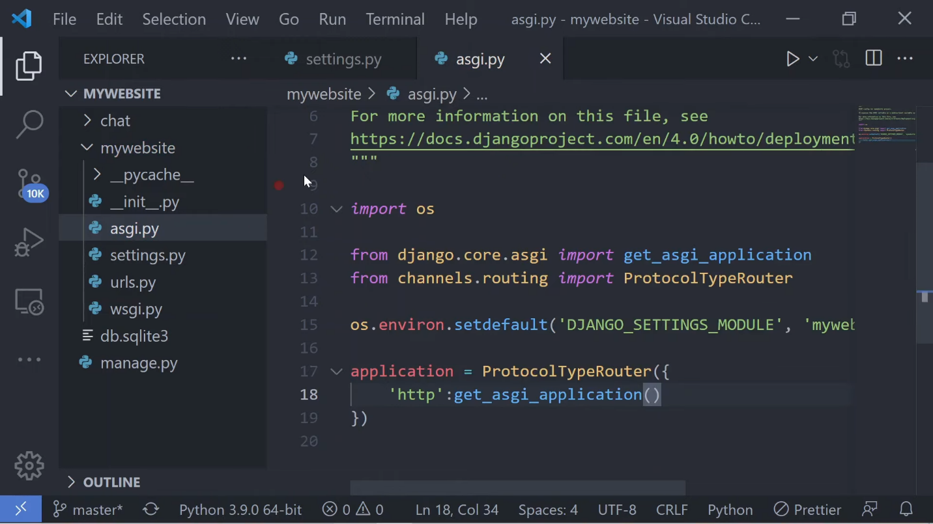

We'll also need to point channels at the root routing configuration, so let's jump back into settings.py and add in ASGI_APPLICATION and set the value to point to mywebsite.asgi.application (or whatever your website was named).

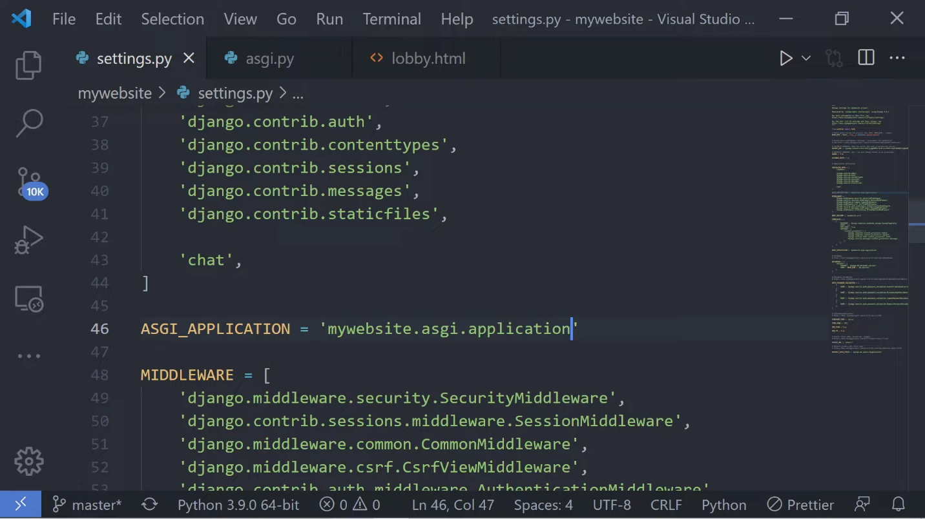

Let's ensure that the channel's development server is working correctly by starting up our server using the run server command...if everything was done correctly you'll see something like this, indicating that the channel's development server has taken over our Django development server.

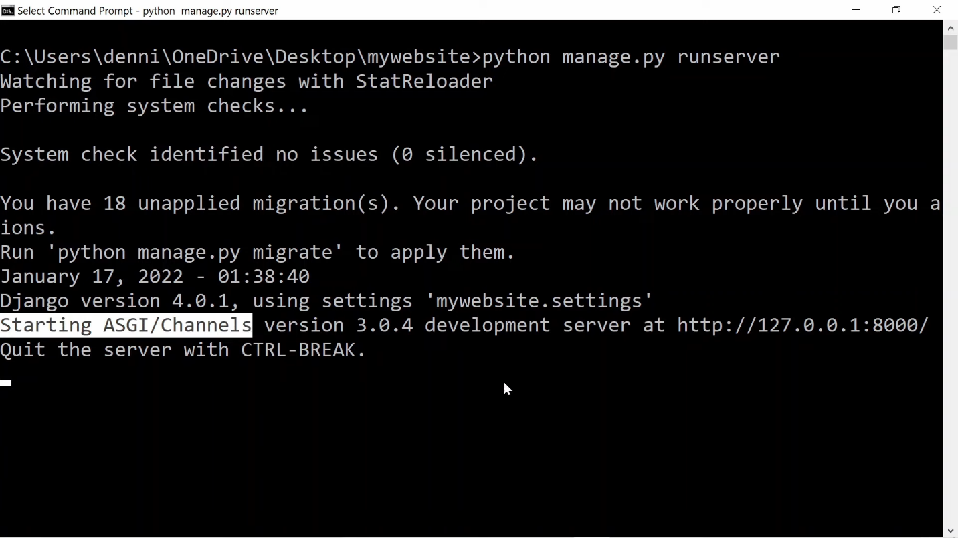

Okay so let's switch gears for a second and jump back to the client side to establish a Websocket connection in our lobby.html file. Let's add in some script tags so we can write some JavaScript directly in our template. To establish a Websocket connection we first need an endpoint to start the handshake.

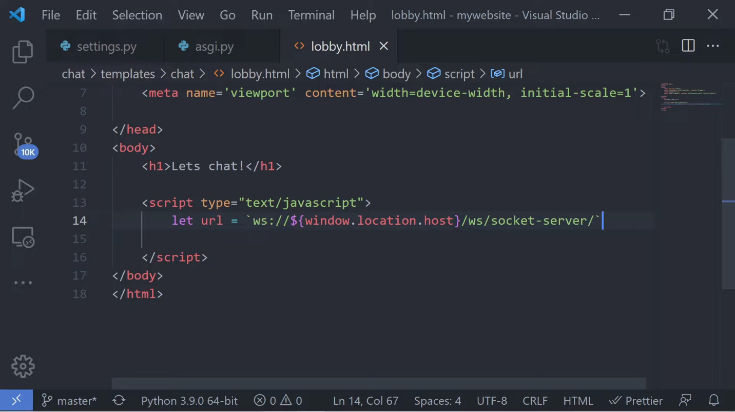

We don't have this URL yet but we'll create it in the next step, so for now let's just go ahead and set the value. Instead of http notice we're going to be using a Websocket connection. We'll then grab the root URL by getting the location host and at the end of the URL just go ahead and add in ws/socket-server/.

Next we'll use the Websocket object to set the chatSocket variable and pass in the URL that we just set. Once we have our chatSocket object we can use the message event to listen to messages from our server. This will fire off anytime our server sends a message from the back end so let's set a function to actually handle this event. For now let's just go ahead and parse the data and console out [Ed: print to the console] whatever message the server sends us.

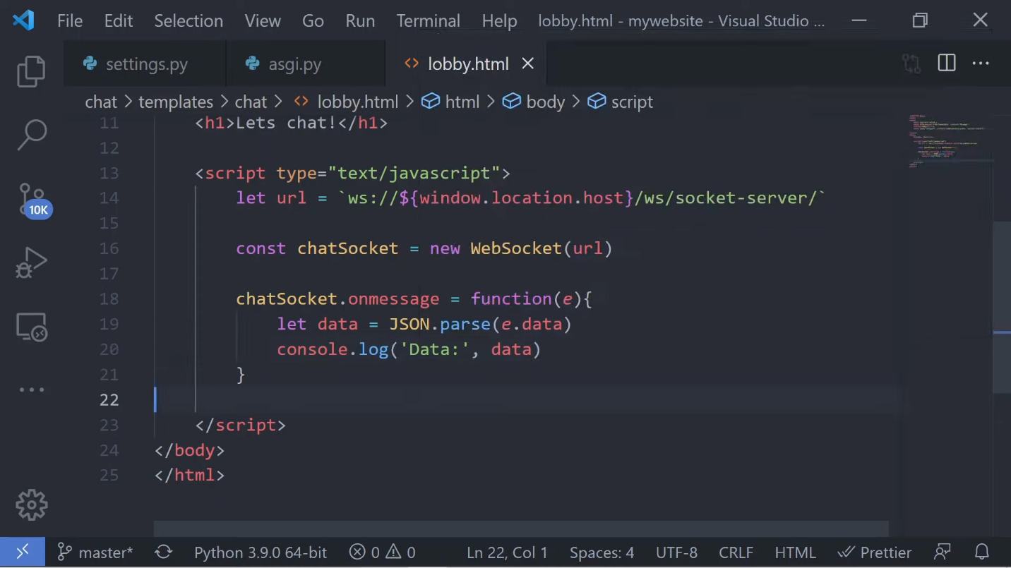

At this point our socket connection is ready but we still have a few parts that we need to build out. Our socket is trying to connect to a server but we have no routers or consumers to actually handle this connection.

Let's open up our browser and take a look at the console.

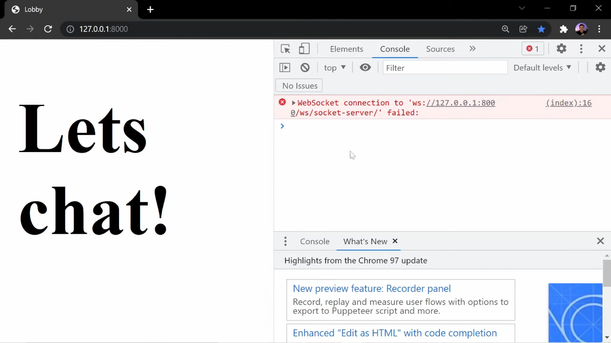

We're gonna see this error because we have no endpoint for this socket to connect to, so let's go ahead and fix it by jumping back into our code and creating some routers and consumers to actually handle this connection on the receiving end.

Back in our code let's go into our chat app and create a file called consumers.py. Like I mentioned earlier, consumers are the channel's version of Django views except they do more than just respond to requests from the client. They can also initiate requests to the client all while keeping an open connection. In the consumers.py file let's go ahead and import json, then let's import WebsocketConsumer. This is going to be what all of our consumers inherit from. Create your first consumer by calling it ChatConsumer and inheriting from the WebsocketConsumer object. We'll call this consumer ChatConsumer because it's going to be responsible for incoming messages from the client and broadcasting them out to anybody that has a connection to this consumer, all in real time.

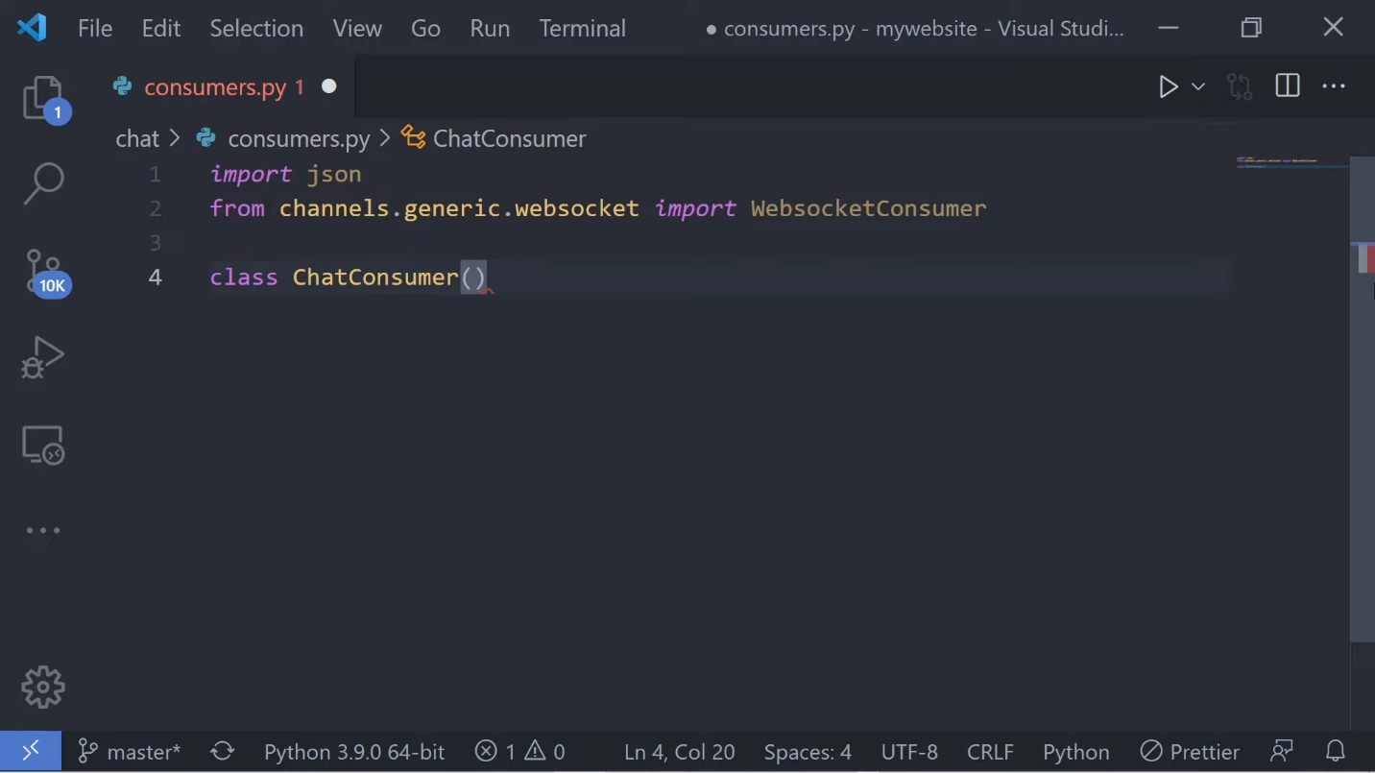

Consumers structure our code into a series of functions. For example, we have a connect method for the initial request that comes in from the client, then we have a receive method for when we receive messages from the client, and we also have a disconnect method to handle what happens when a client disconnects from this consumer.

In the connect method let's first create the connection from the client then send a message back notifying the client that the connection was made. For now we'll just receive the message on the client side and console out [Ed: print to the console] just to make sure that the connection was established. The data we send back will just be a string-ified object with a type and a message value and these values are completely up to us, so go ahead and add in whatever you want. Here in my case I'm just adding connection_established as the type just as a note to myself so I can see this on the front end.

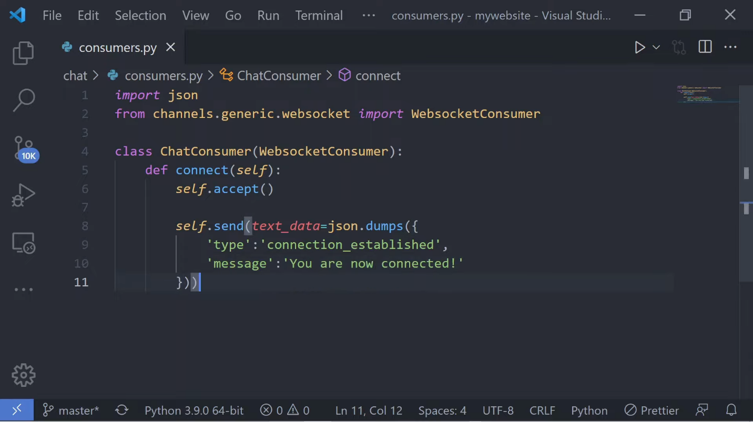

In order to use this consumer we're going to need to set up some routing, so in your app create a routing.py file and in this file go ahead and import the re_path method. We use re_path due to the limitations that we have in url_router. Okay, so now we're going to want to import our consumers into this file and start setting up the Websocket URL patterns list in the Websocket URL patterns. Let's go ahead and use the re_path method and set the route to this new chat consumer. In the path method we're going to set this endpoint as what we specified in the front end whenever we try to make that initial socket connection.

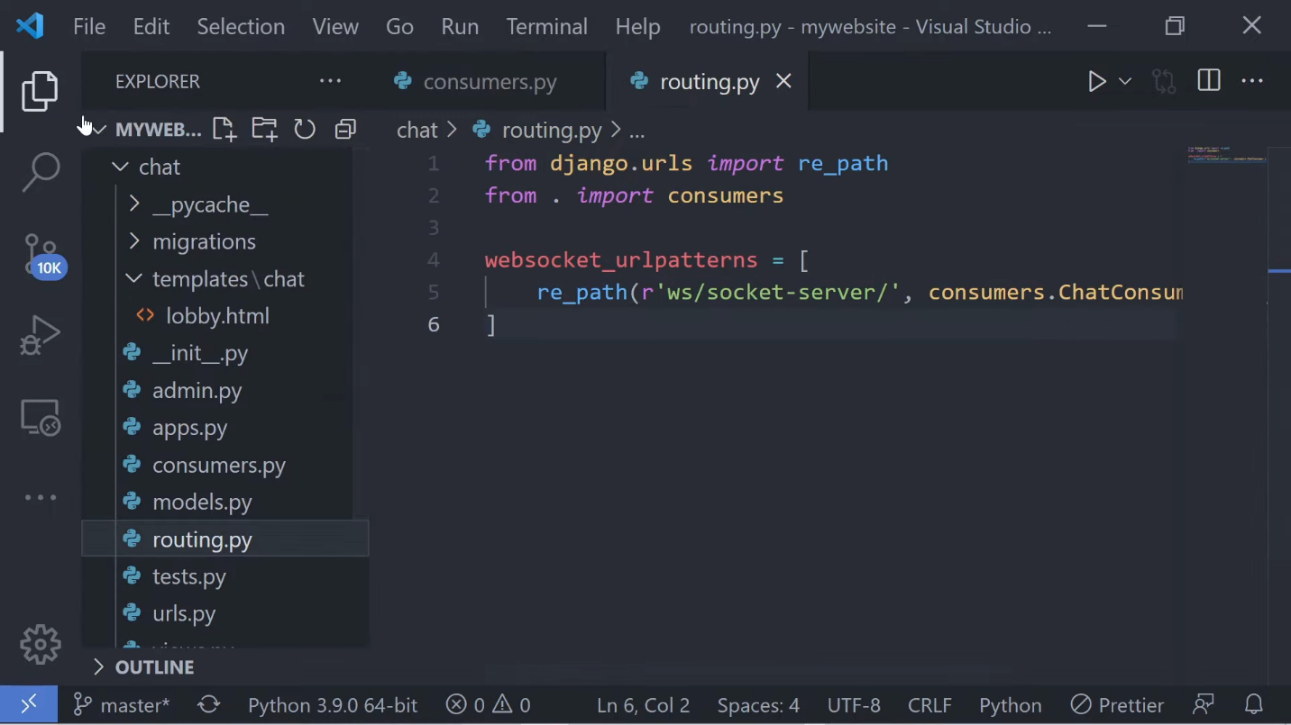

Back in our asgi.py file let's go ahead and import the URLOouter method and AuthMiddlewareStack. AuthMiddleware and Channels support standard Django authentication where the user details are stored in a session. (AuthMiddleware requires SessionMiddleware to function, which itself requires CookieMiddleware. For convenience these are all provided as a combined callable called AuthMiddleWareStack.)

Make sure you import your routing.py file. Inside of the ProtocolTypeRouter add Websocket to the list of protocols and use the AuthMiddlewareStack method to wrap the URLRouter. In the URLRouter we'll just pass in the Websocket URL patterns list from our routing.py file.

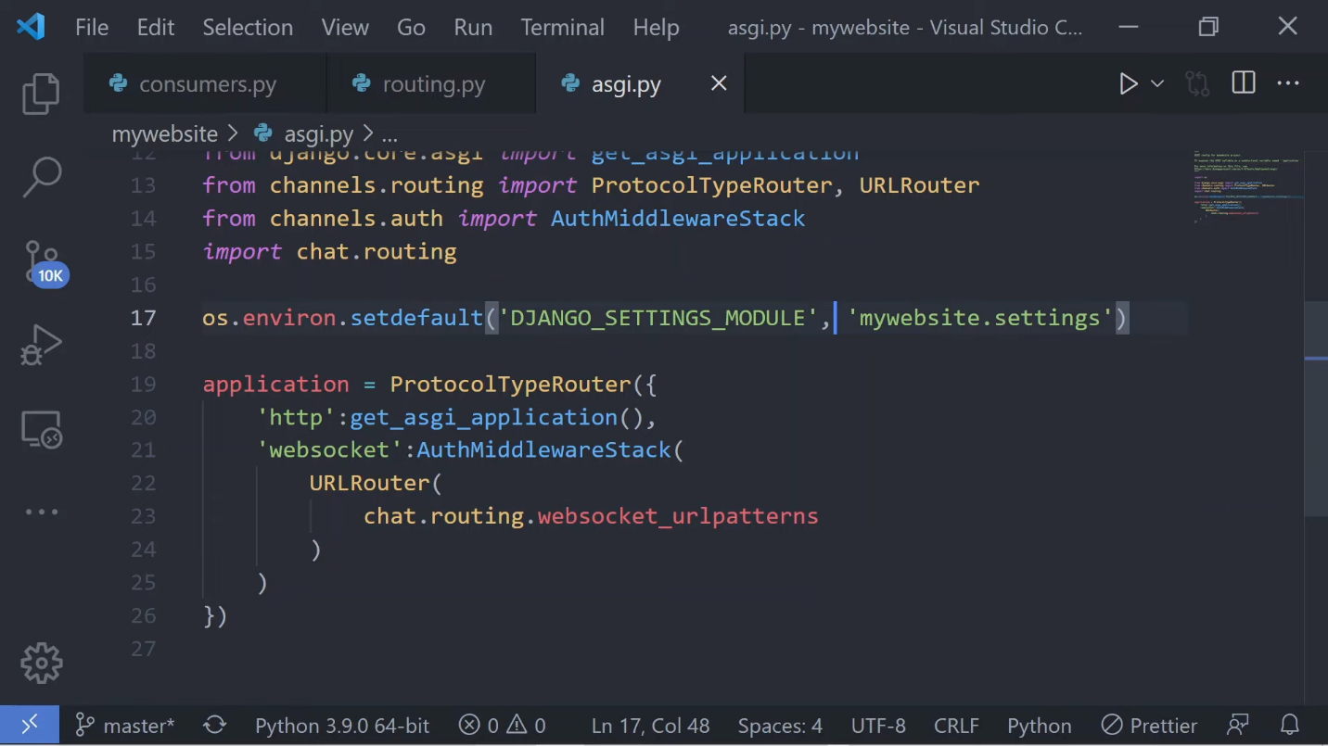

Once this is all set, open up your terminal and run migrations to apply the database changes and start up your development server.

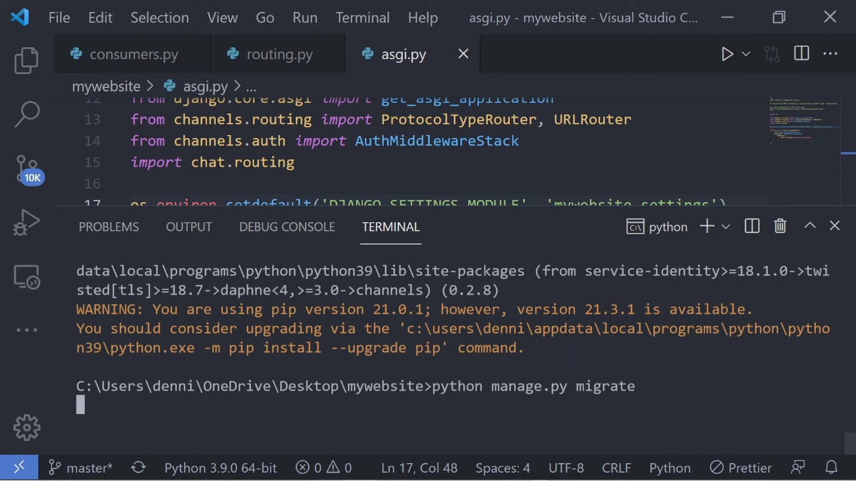

We need these migrations because the Django session framework needs a database. Now if you jump back into your browser and view the console you should see the data [printed] out without any errors.

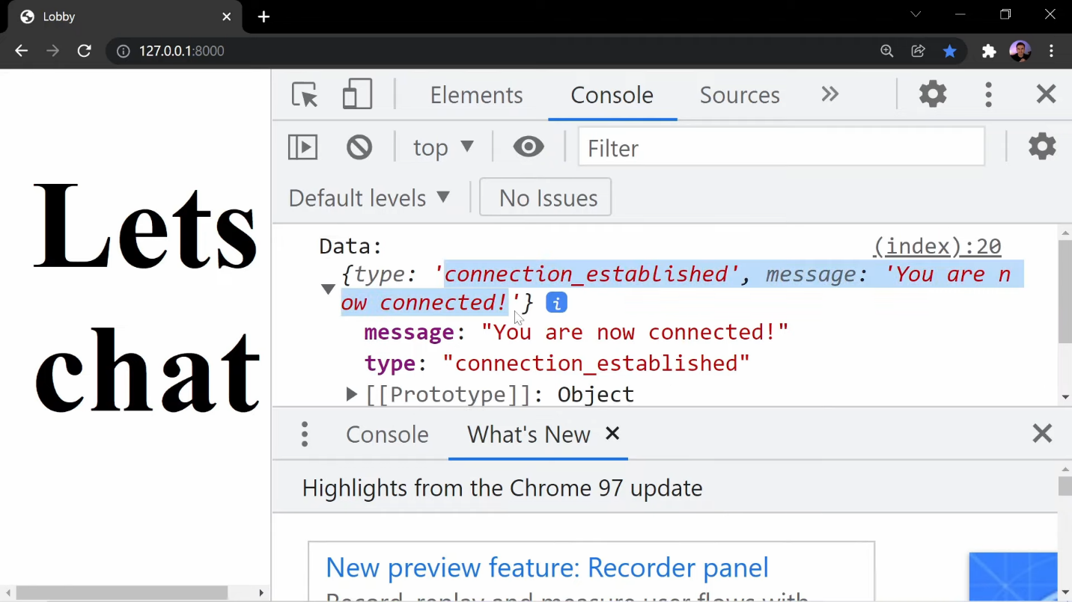

This message was sent from our consumer on the initial connection and the cool thing about this message is that it's not a response that you'd get back from a typical view. This request was actually initialized by the server. At this point we did a whole bunch of work for not much functionality, so let's keep adding to this so we can see the real value of Django Channels.

Let's jump back into our lobby.html file and create a form we can send messages from. Let's give this form an ID and inside of the input value let's set that to text and give it the name of “message”. We'll need an ID for this form because we will add event handlers later to handle form submissions.

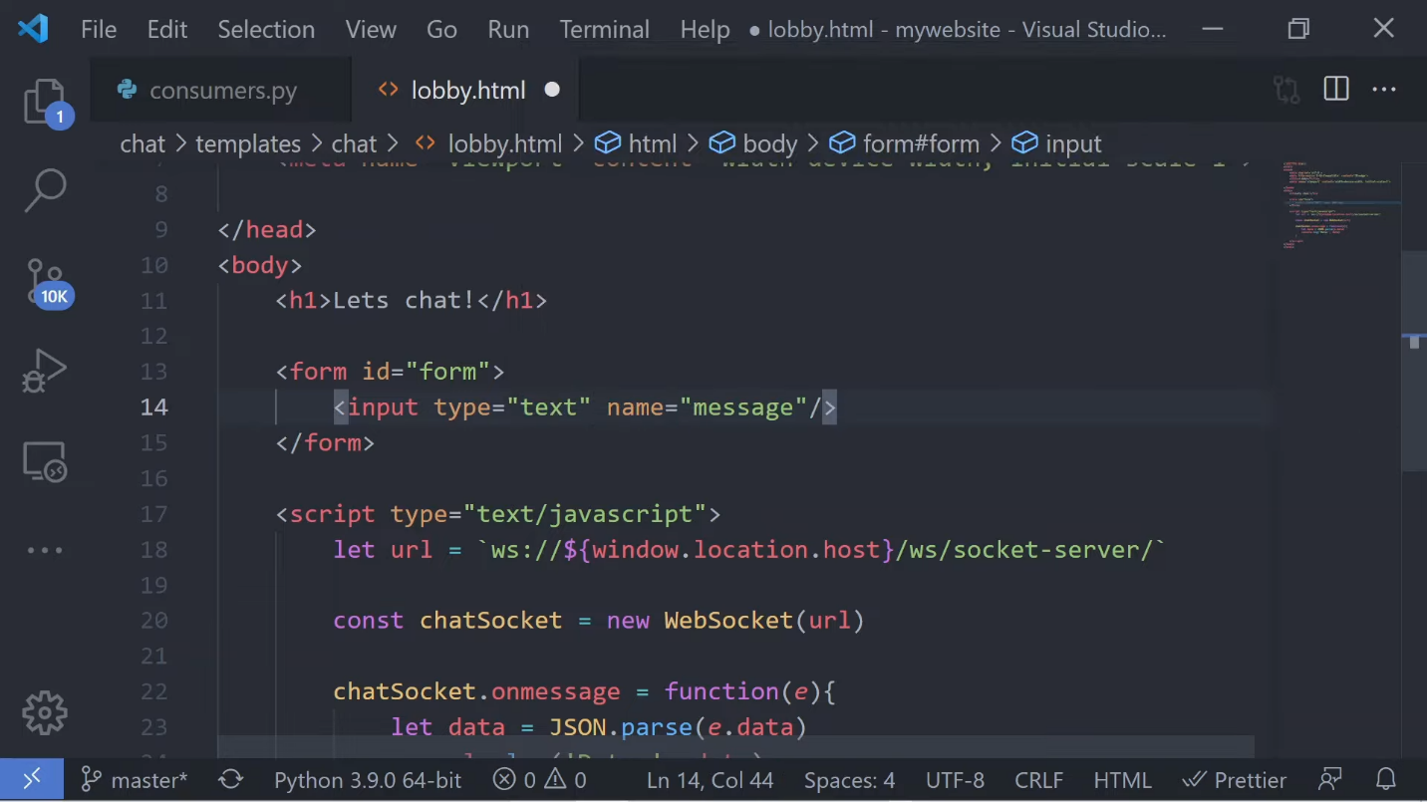

Down in our script tags let's go ahead and query our form by using document.getElementById, grab the form’s ID, and set this all to a variable called “form”. Next we'll add an event handler to our form to handle form submissions and I'm going to set this to an arrow function and the first thing I want to do is prevent the default actions on submission. Let's grab the value of the form message and set this to the message variable. Now we can string-ify the message and send it to the chat room using the send method from our Websocket object, which is stored inside of the ChatSocket variable. Once this message is sent we want to make sure to reset this form by calling the reset method.

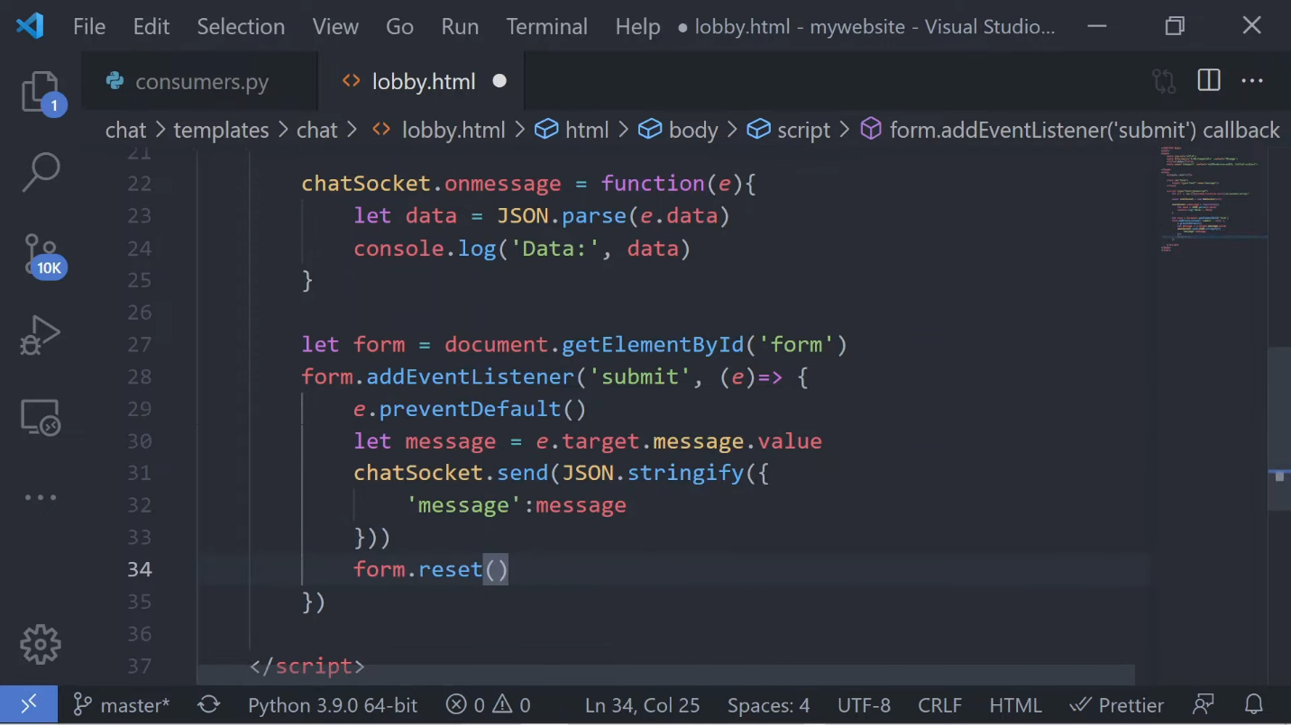

In our ChatConsumer let's set the receive method. This method will listen for incoming messages from the client, so what we'll want to do here is parse the data and then handle the response. Set the message variable to the data that was sent from the client.

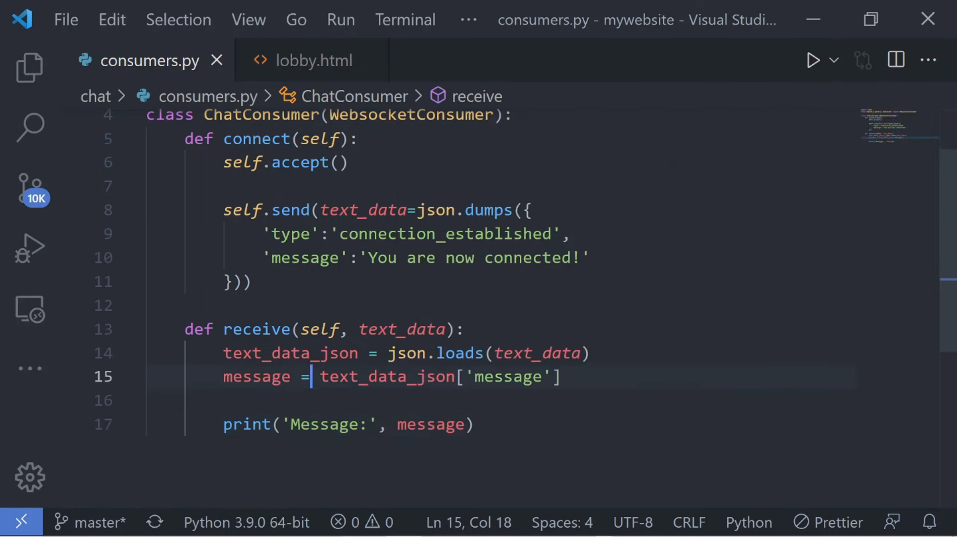

For now let's test the receive method by simply printing out our message and opening up the browser in the terminal side-by-side. Let's just write a few messages here and see what gets printed…

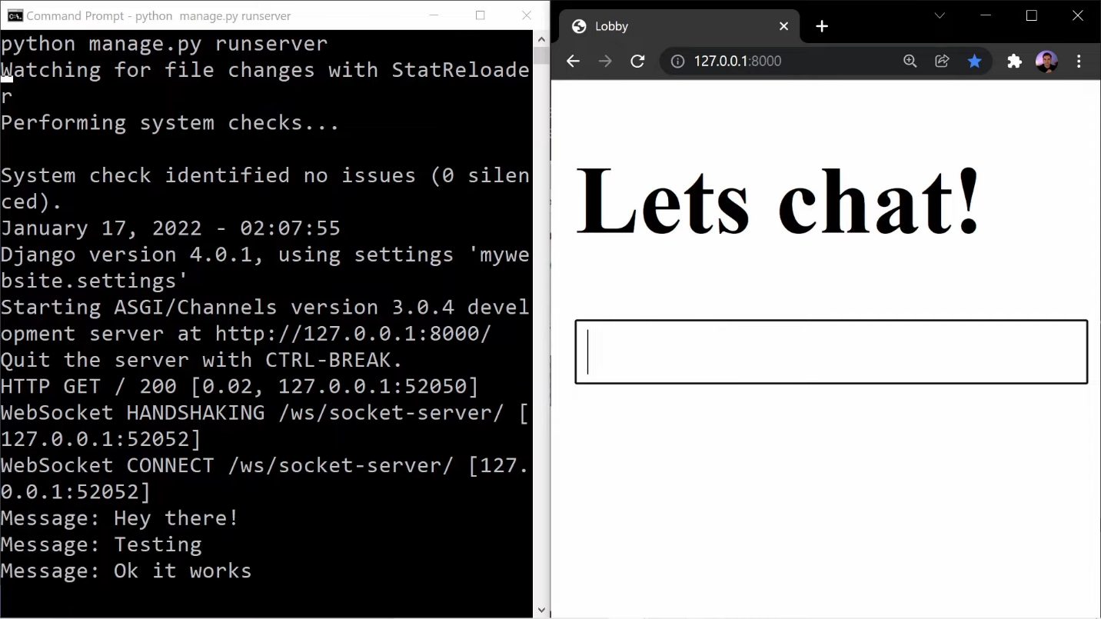

…and there we go. I see a few messages and it looks like everything's working so far. At this point our socket connection is only between one client and our server. Whenever a consumer receives a message we want to be able to broadcast this message out to everybody that has a connection with this consumer.

Let's first take a look at the issue by jumping back into our consumers file and use the send method to send a message back to the client whenever we receive a message using the send method. We'll want to string-ify the data and add in the type of chat so we can use this information in the front end and pass in the actual message value in the front end. Let's jump to our messages function and handle the incoming messages from the server by first identifying the message type.

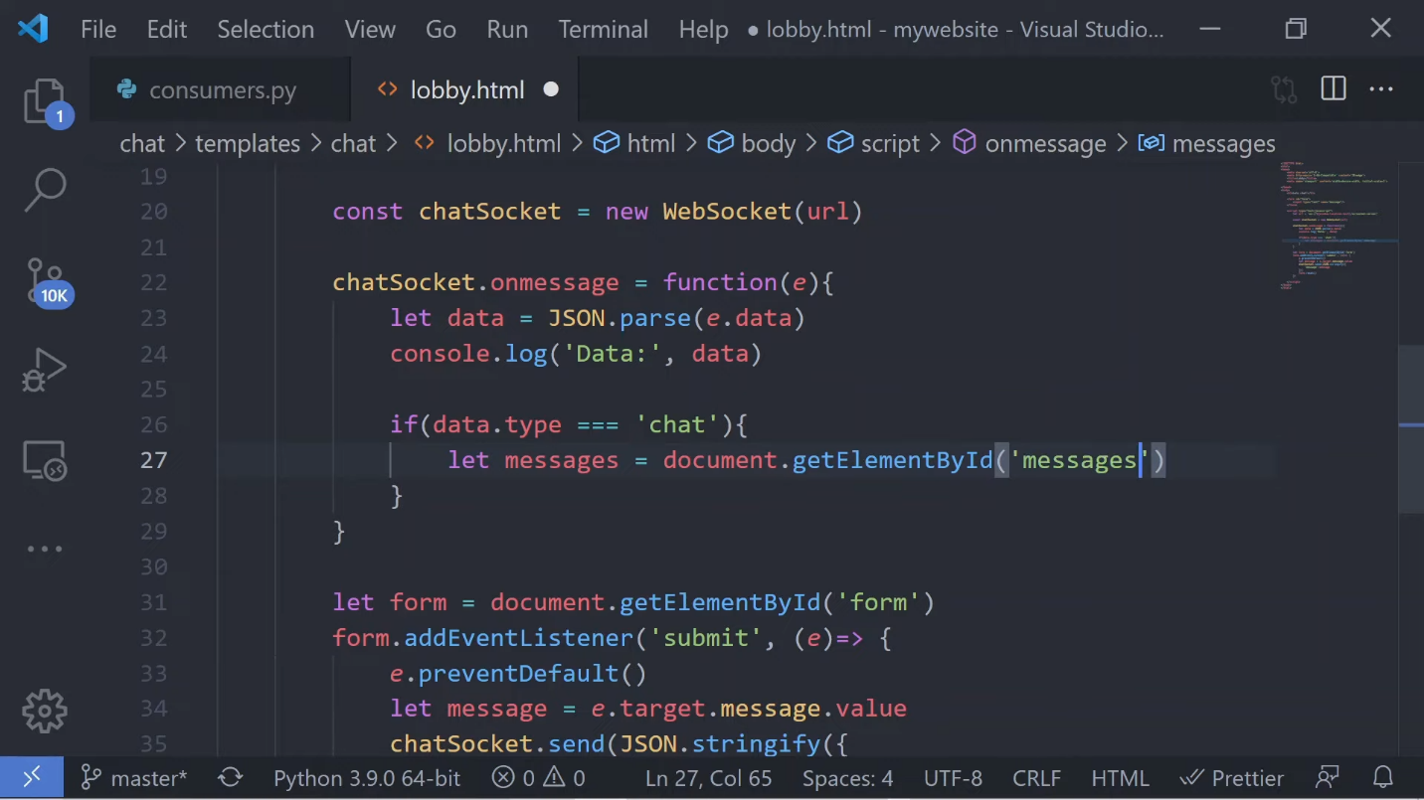

Let's query the messages wrapper first and then we'll create a wrapper in the HTML. This will be a div with the id of “messages” and will remain empty until users begin to add messages on that form submission. We'll then take the messages container and simply append the new message to the beginning of the wrapper and we can do this by using the insertAdjacentHTML method. Now in this method we'll set two parameters. The first one will be beforehand so the message appears at the top, and in the second parameter we'll use our template literals (so those are backticks instead of quotes). And we'll create a div to wrap the actual message that we're gonna add in here, so the message will be in a paragraph tag, and we can throw in the message as a variable.

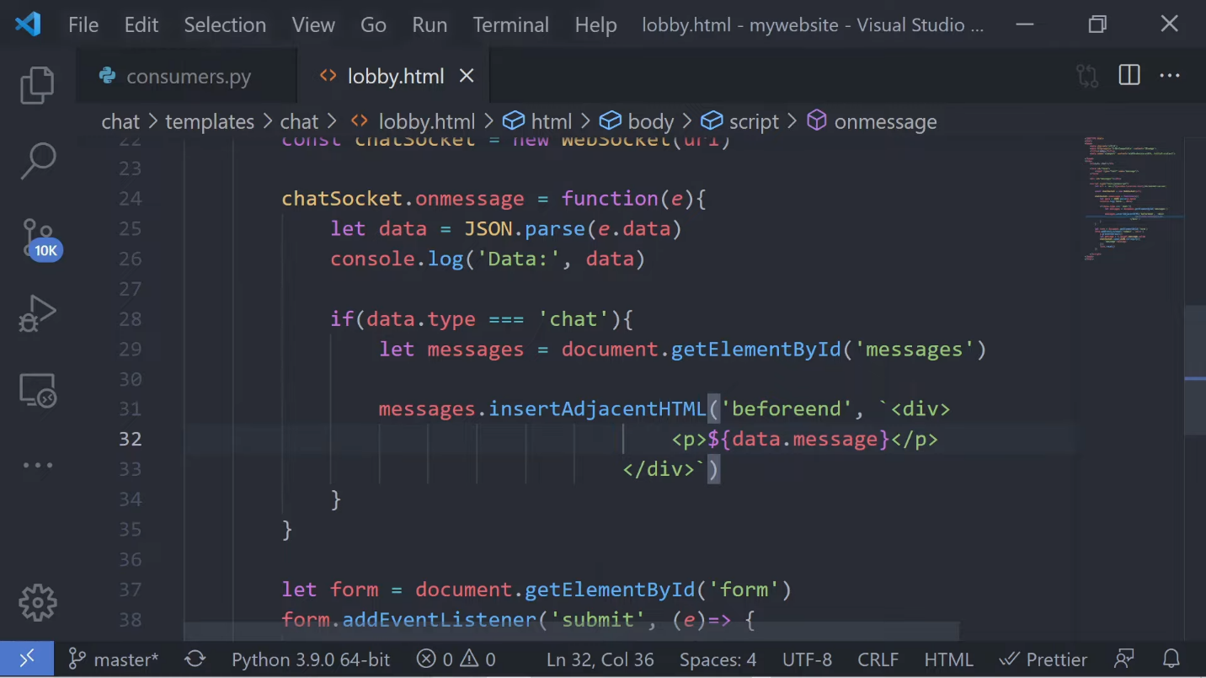

When i open up two tabs my desired outcome is to see the chat message appear in both tabs as I type the message, but as you can see at this point each user is only getting back their own message.

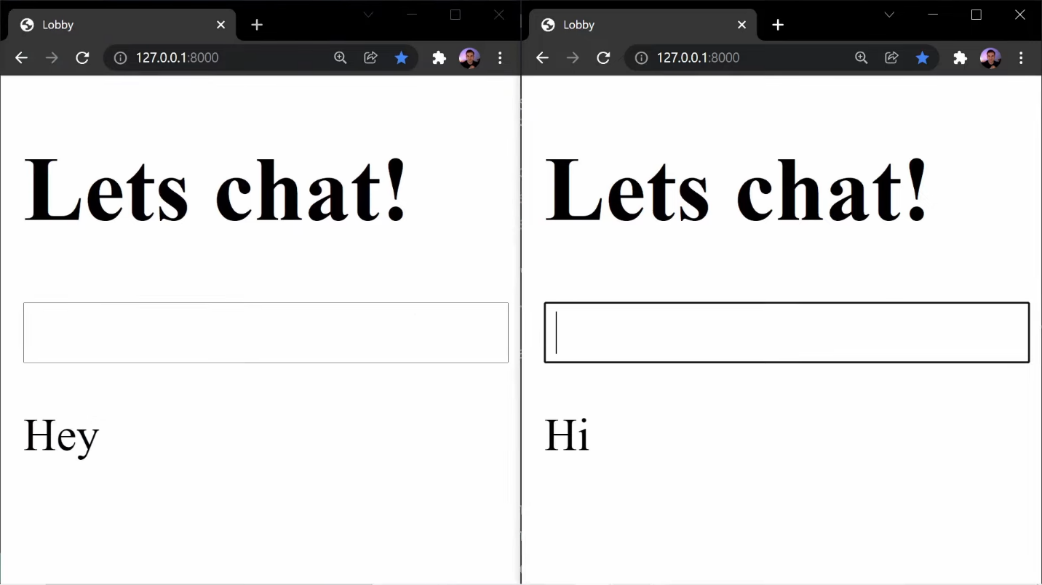

As I mentioned earlier this issue is occurring because each browser has an independent connection with a socket to the server so these two tabs don't actually know about each other. So let's go ahead and actually fix this in the next step.

To display messages to all users we're going to need to enable something called Channel Layers. Channel Layers allow us to create an interaction between different instances of an application for real-time communication.

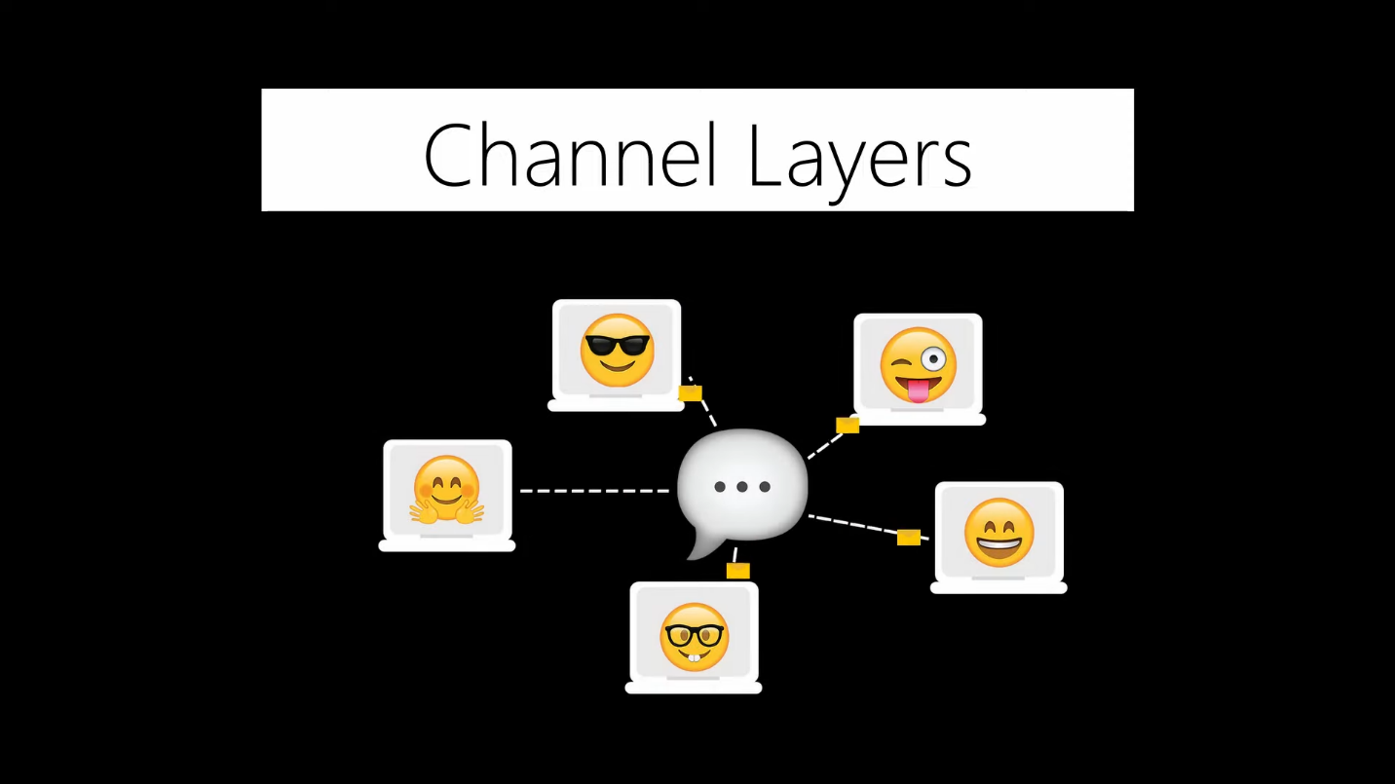

Okay so now let me try to explain Channel Layers before we actually get into using them, because I read through the documentation and it made sense to me (because I'm really familiar with Django) but I want to try to explain this in a way where everybody can understand and really try to simplify things. So I'm going to go away from the technical definition and do the best that I can here.

So Channel Layers are an entirely optional part of Django Channels and they provide a way for multiple consumer instances to talk to each other and other parts of Django. Now a Channel Layer provides us with groups and channels. Think of groups like chat rooms that store information about users in a particular room and these rooms will be stored inside of an in-memory database. Inside of these groups we have a bunch of channels, also known as users. A channel is simply a mailbox representing a user in a particular group, and anybody that knows that specific channel name can send a message to that user via that channel. So you can send a message to that user's channel and that user will receive that message.

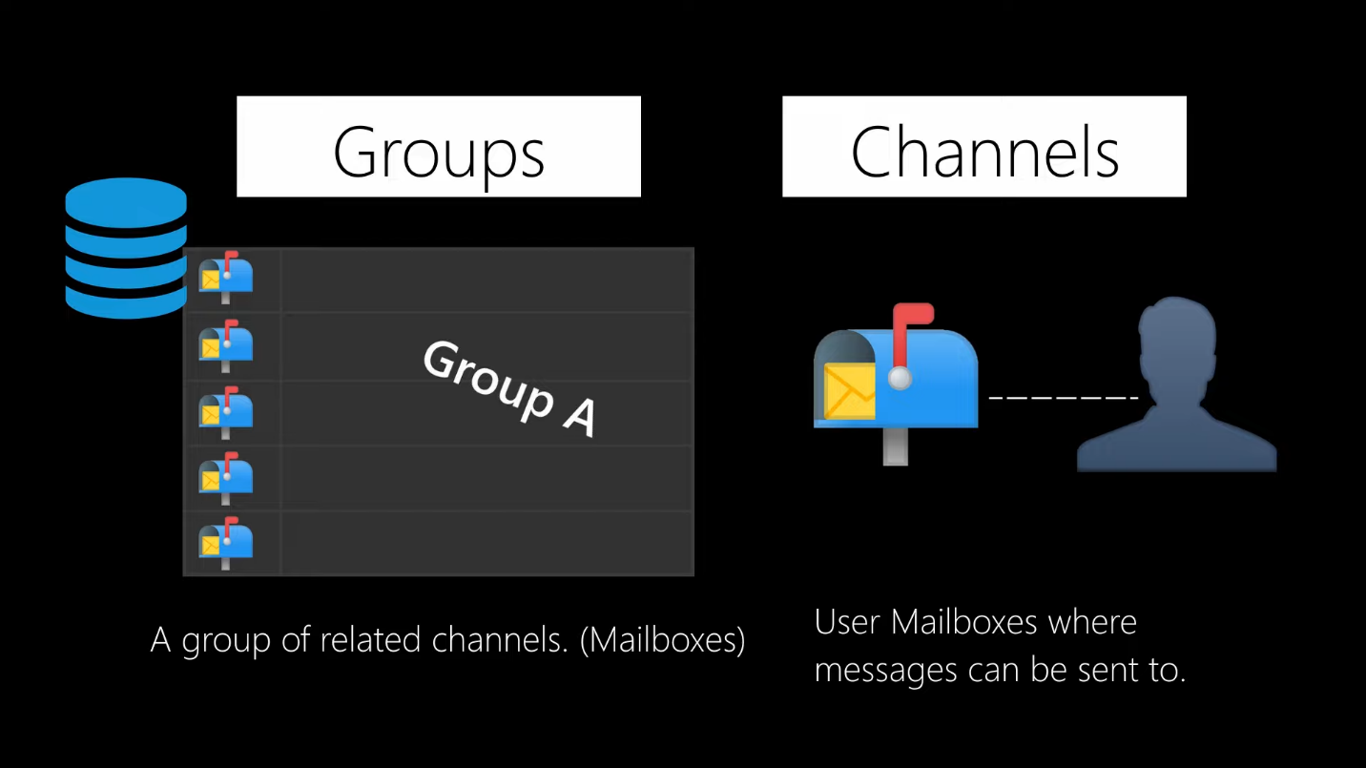

Now with channels what we're going to do here is anytime we create a chat room we're going to have a group that represents a specific room. So anytime users join a chat room we're going to take that user's channel and we're going to add it to that group. So now whenever a user sends a message this message will actually go to the group that they sent it to and because a group is simply a collection of channels (and remember channels are now just mailboxes that represent users) we're going to be able to broadcast that message to every single channel inside of that group. So this is how a user can send a message and that message can be spread out to every single user in that group and this is how we can actually have that communication happen in real time.

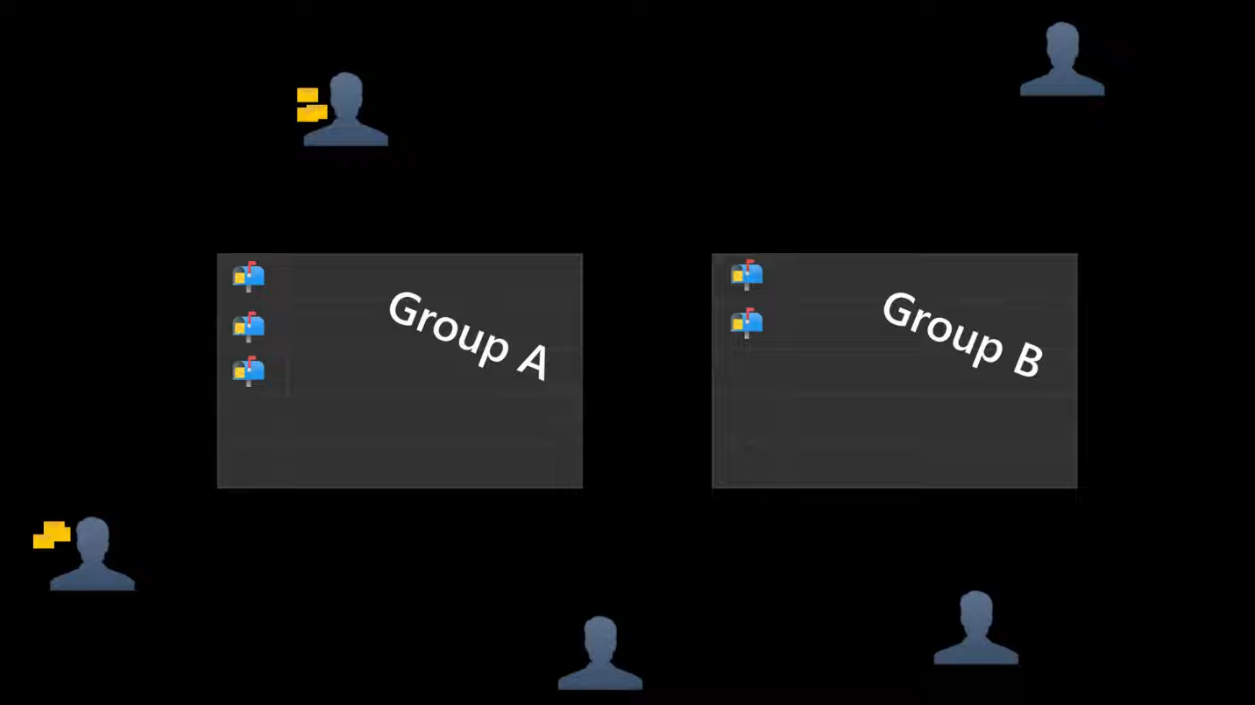

So let's go ahead and see this in action by first enabling Channel Layers and then we'll start building all of this out.

To enable Channel Layers we're going to want to jump back into our settings.py file and set the Channel Layers value. In a production environment we'll want to use something like Redis as our in-memory database, in this video however I'm going to skip the Redis integration and simplify things by using InMemoryChannelLayer.

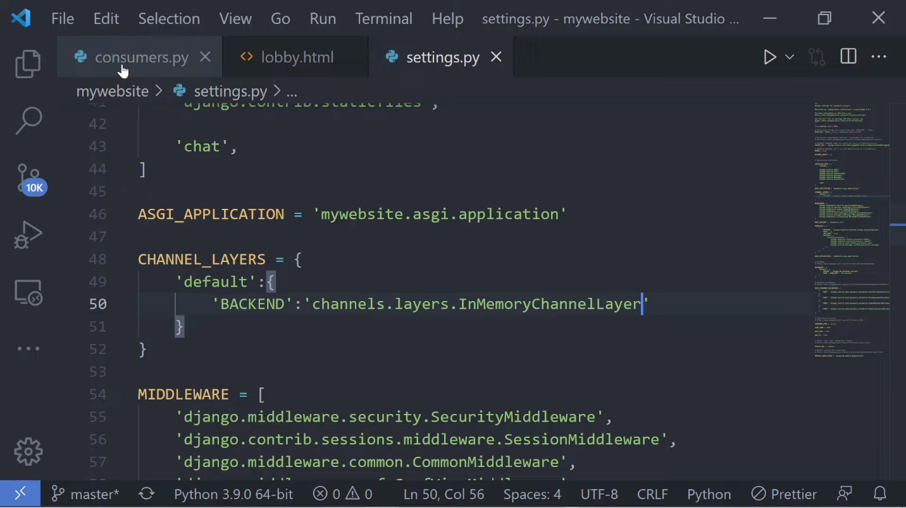

As a side note using InMemoryChannelLayer is for testing only and should not be used in production, so I'll be sure to teach you how to configure this with Redis and be more production-level ready. Just make sure you're subscribed and I'll come out with a full tutorial where we'll build out a chat application and we'll go much more in depth in this topic.

So now inside of our consumers.py file let's go ahead and import async_to_sync from asgirev and let's go ahead and get rid of some code here so we can clean up our consumers a bit. On the initial connection we'll first want to set a group name. Normally this would be a dynamic value from our URL or whatever room the user joined, but in this case because it's an oversimplified application we're only going to have one group and we're going to call it test and all users will be added to this group. Using the async_to_sync method, we'll access the channel layer and call the group_add method. To add a user's channel to the group we simply specify the group name and our user's channel name.

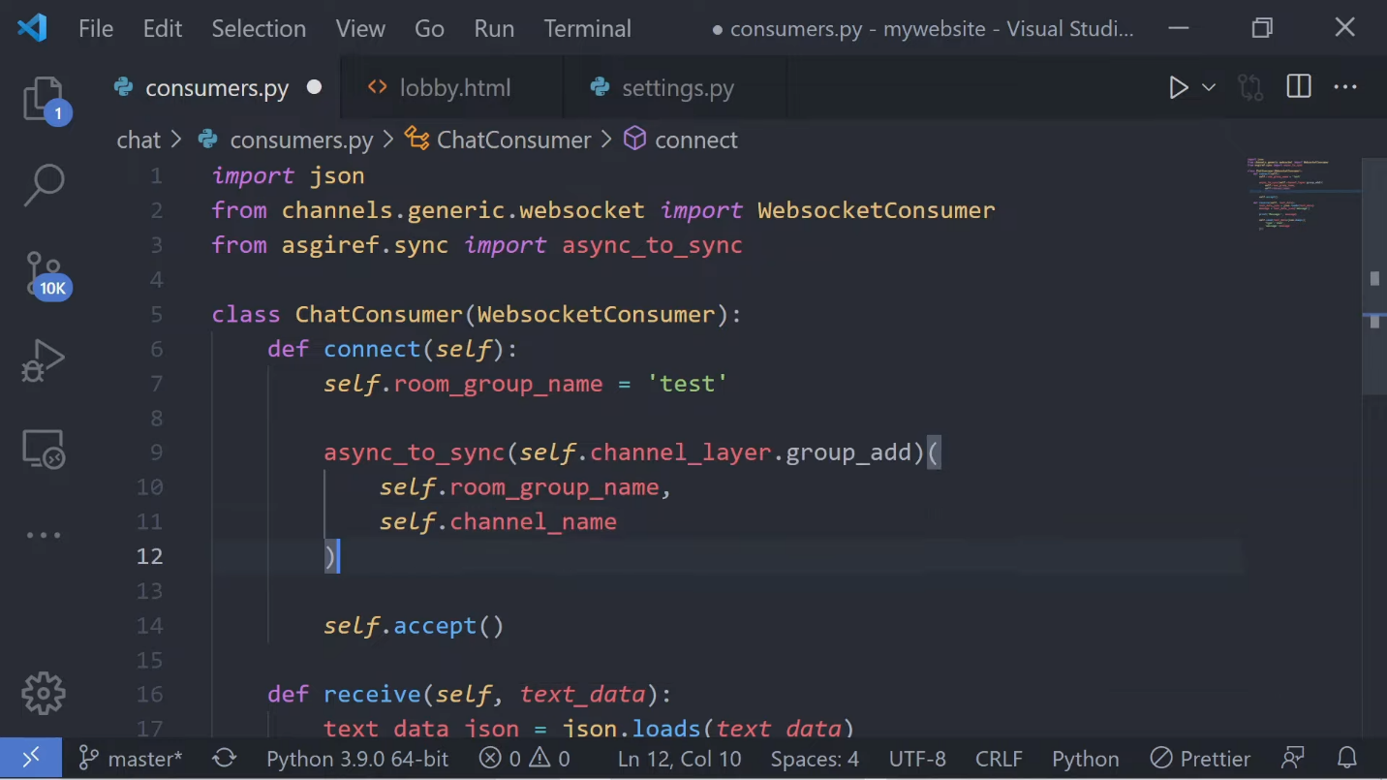

Now for the channel name we don't need to create this this will be created for us automatically for each user.

In the receive method let's go ahead and clear out some code and use async-to_sync again. Now in this case we'll use the group_send method to broadcast a message to every specific user in this group. We'll specify the group name that we want to send this message to along with the message and the name of the function that we want to have handle this event. We haven't created the chat message function yet so for now just go ahead and add in the type value of “chat_message” and we'll create the function next.

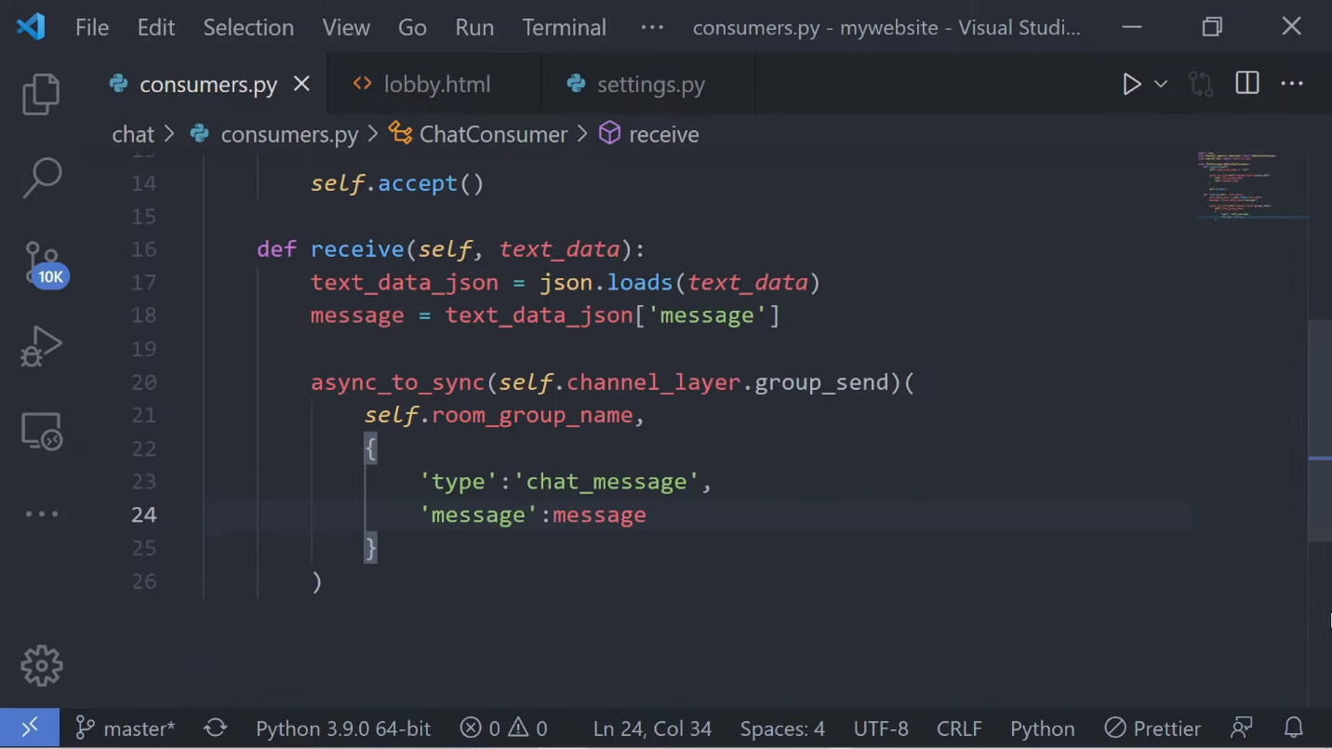

Below the receive method let's go ahead and create a function called chat_message. We'll then pass in self and the event and use the event object to retrieve the message that was sent. Now from this function we can call the send method and because this message was sent to a group every user that has a channel in this group will receive this message and this will be broadcasted out in real time.

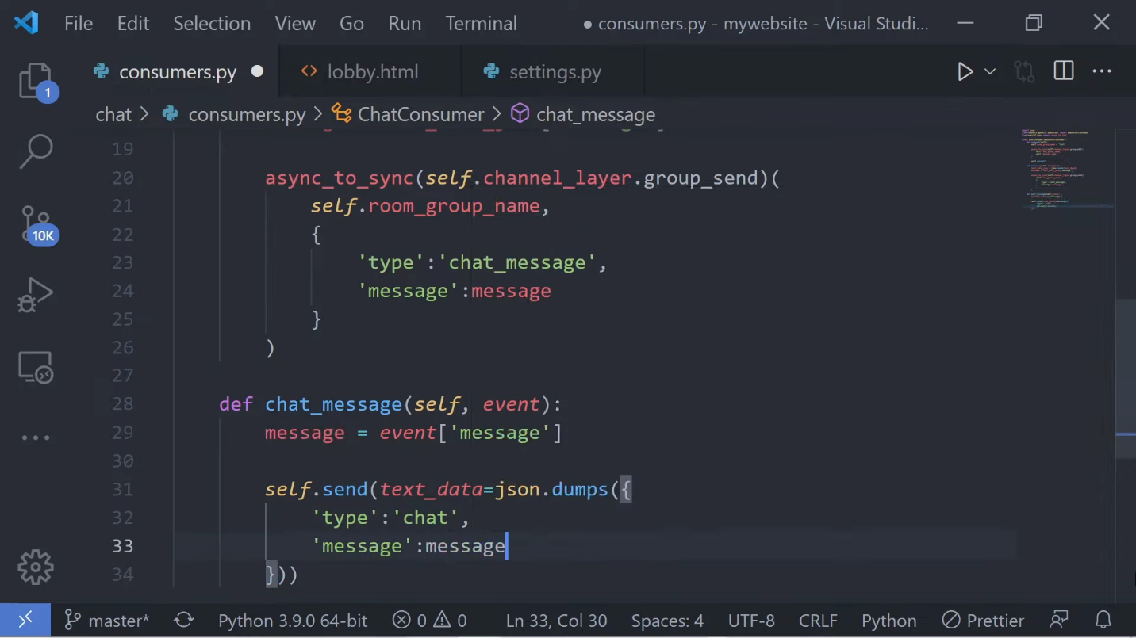

So let's go ahead and actually open this up. We'll open two tabs up…and let's test this out in the browser. If I open up two tabs side-by-side I can now write a message and see the message displayed in both tabs here, so when users join this website as long as they're inside of the same group everybody's going to see the message in real time as I type this out and hit send.

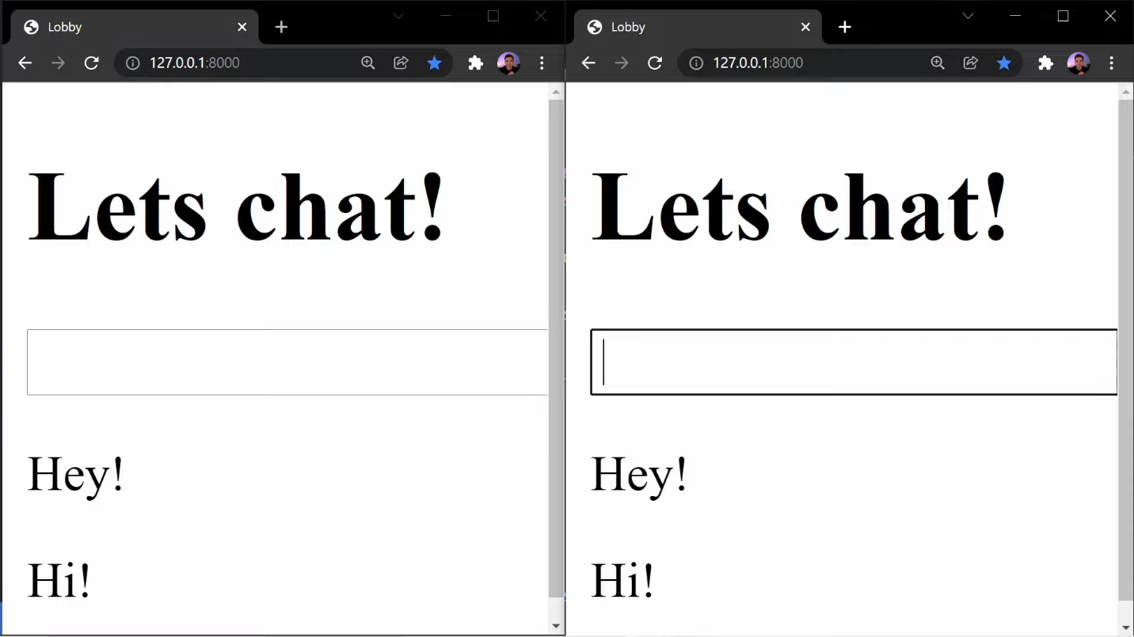

So that's it for this video. I hope it gave you a high-level overview of Django Channels, and be sure to keep an eye out for my more in-depth tutorial on Django Channels where I'll build out a full chat application with multiple rooms and we'll take time to actually explain each part as we code it out and I'll be sure to show you how to integrate Channel Layers with Redis so your application will be more production-level ready